**NAME:** Yash Shah

**CLASS:** TE COMPS **BATCH:** D

# ROLL NO: 55

**UID:** 2018130049

***Experiment 8***

**AIM**

To establish connection between server client using sockets.

**THEORY**

**What is socket programming?**

Socket programming is a way of connecting two nodes on a network to communicate with each other. One socket (node) listens on a particular port at an IP, while other socket reaches out to the other to form a connection. Server forms the listener socket while client reaches out to the server. They form the backbones of web browsing.[1]

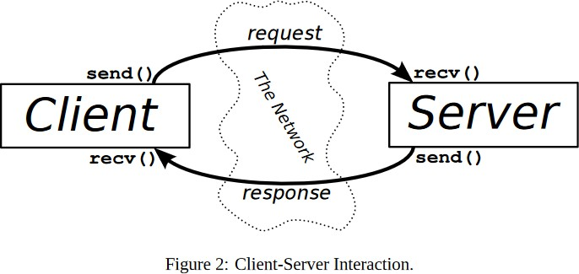

The exchange of information between client and server is summarized in the above diagram.

A server has a bind() method which binds it to a specific ip and port so that it can listen to incoming requests on that ip and port. A server has a listen() method which puts the server into listen mode. This allows the server to listen to incoming connections. And last a server has an accept() and close() method. The accept method initiates a connection with the client and the close method closes the connection with the client.

A client has a connect() method which opens a TCP connection to the hostname on the port. Client also has a recv() method which receives the message.

**CODE**

**Server:**

import socket

print(“server”)

s = socket.socket(socket.AF_INET, socket.SOCK_STREAM)

s.bind((socket.gethostname(), 8000))

s.listen(5)

while True:

clientsocket, address = s.accept()

print(f'Connection established with {address}')

clientsocket.send(bytes('Hello World!', 'utf-8'))

clientsocket.close()

# Client:

# import socket

# s = socket.socket(socket.AF_INET, socket.SOCK_STREAM)

# s.connect((socket.gethostname(), 8000))

# msg = s.recv(1024)

# print(msg.decode('utf-8'))

# s.close()

**OUTPUT**

**Server:**

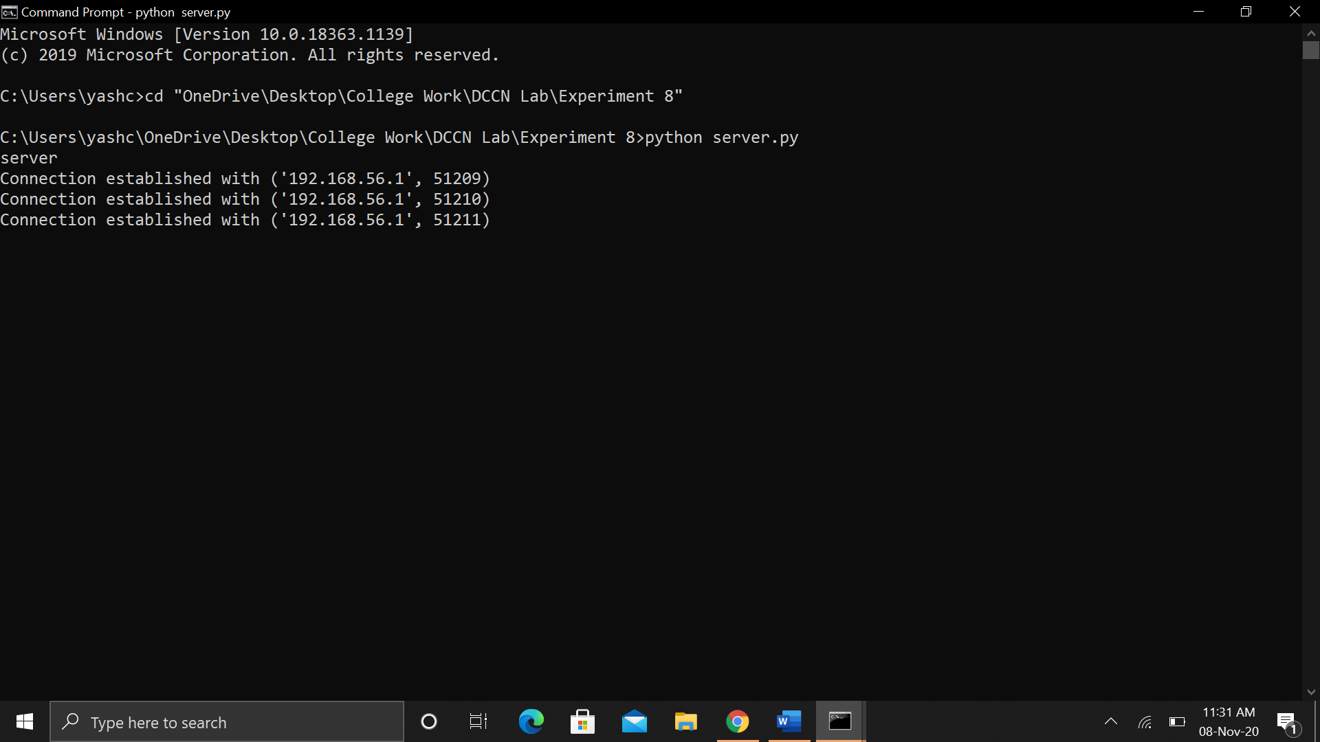

**Client:**

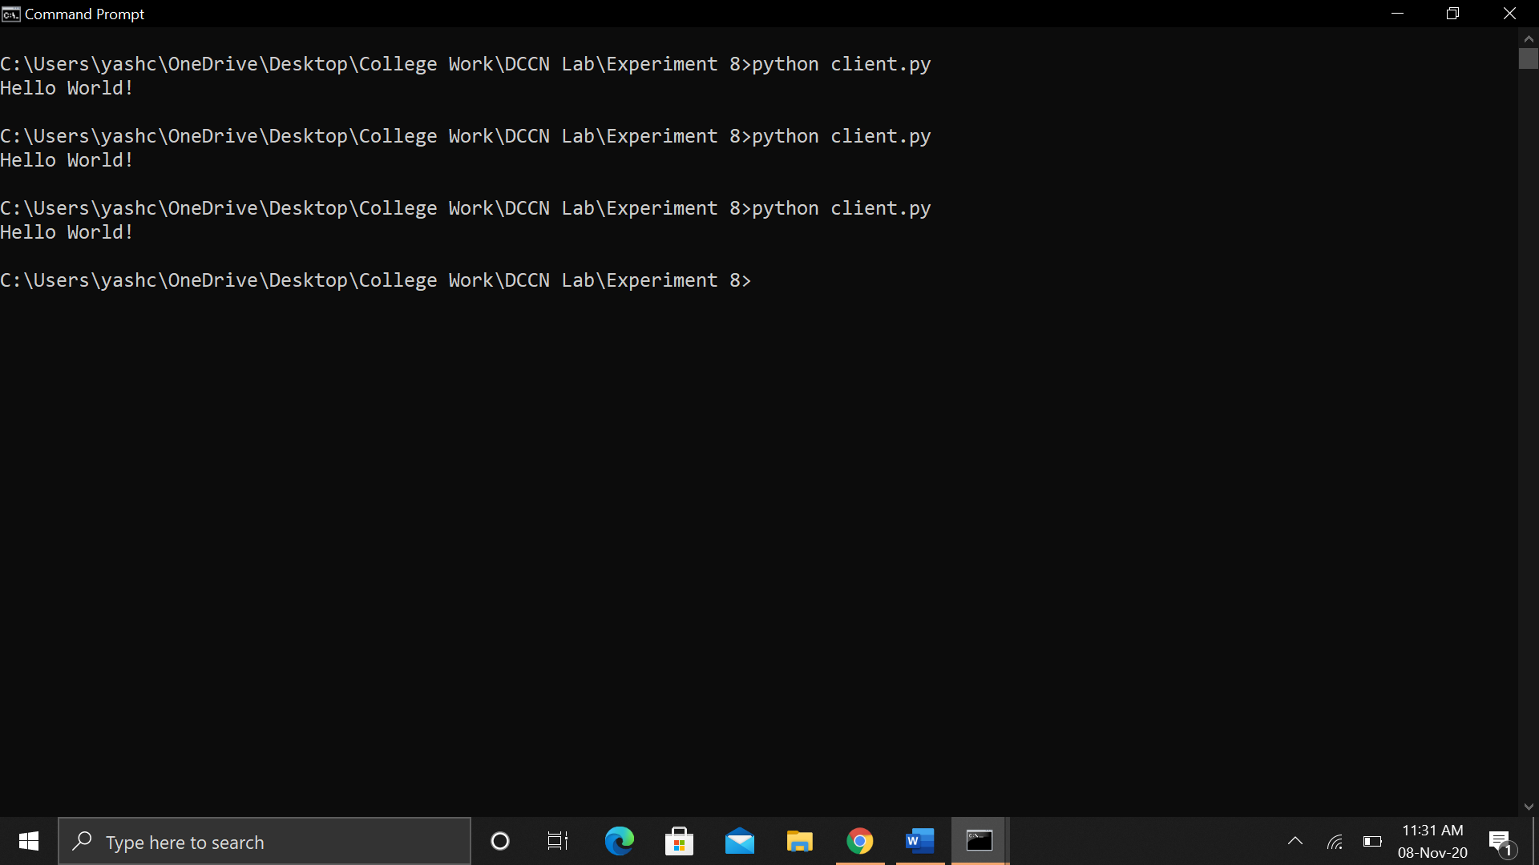

**CONCLUSION**

I understood the basics of socket programming and established a simple connection between client and server using the same.

**REFERENCES**

[1] <https://www.geeksforgeeks.org/socket-programming-python/>